ACIDS AND ALKALIS NOTES

Acids

An **acid** is a [molecule](https://en.wikipedia.org/wiki/Molecule) or [ion](https://en.wikipedia.org/wiki/Ion) capable of either donating a [proton](https://en.wikipedia.org/wiki/Proton) (i.e. hydrogen ion, H+)

Aqueous acids have characteristic properties that provide a practical description of an acid.

Acids form aqueous solutions with a sour taste, can turn blue [litmus](https://en.wikipedia.org/wiki/Litmus) red, and react with [bases](https://en.wikipedia.org/wiki/Base_(chemistry)) and certain metals (like [calcium](https://en.wikipedia.org/wiki/Calcium)) to form [salts](https://en.wikipedia.org/wiki/Salt_(chemistry)). The word *acid* is derived from the [Latin](https://en.wikipedia.org/wiki/Latin) *acidus*, meaning 'sour'. An aqueous solution of an acid has a [pH](https://en.wikipedia.org/wiki/PH) less than 7 and is colloquially also referred to as "acid" (as in "dissolved in acid"), while the strict definition refers only to the [solute](https://en.wikipedia.org/wiki/Solute). A lower pH means a higher **acidity**, and thus a higher concentration of [positive hydrogen ions](https://en.wikipedia.org/wiki/Hydron_(chemistry)) in the solution. Chemicals or substances having the property of an acid are said to be **acidic**.

Common aqueous acids include [hydrochloric acid](https://en.wikipedia.org/wiki/Hydrochloric_acid) (a solution of [hydrogen chloride](https://en.wikipedia.org/wiki/Hydrogen_chloride) that is found in [gastric acid](https://en.wikipedia.org/wiki/Gastric_acid) in the stomach and activates [digestive enzymes](https://en.wikipedia.org/wiki/Digestive_enzymes)), [acetic acid](https://en.wikipedia.org/wiki/Acetic_acid) (vinegar is a dilute aqueous solution of this liquid), [sulfuric acid](https://en.wikipedia.org/wiki/Sulfuric_acid) (used in [car batteries](https://en.wikipedia.org/wiki/Car_battery)), and [citric acid](https://en.wikipedia.org/wiki/Citric_acid) (found in citrus fruits). As these examples show, acids (in the colloquial sense) can be solutions or pure substances, and can be derived from acids (in the strict sense) that are solids, liquids, or gases. [Strong acids](https://en.wikipedia.org/wiki/Acid_strength) and some concentrated weak acids are [corrosive](https://en.wikipedia.org/wiki/Corrosive_substance)

Now we explore the chemical properties of acids and bases. Let us get started with acids,

* Acids change the colour of litmus from blue to red.
* They convert the colour of Methyl Orange from Orange/Yellow to Pink.
* Acids turn the pink colour of Phenolphthalein to colourless.
* Acids can conduct [electricity](https://www.toppr.com/guides/physics/electricity/).
* Some Acids are highly corrosive in nature which means that they corrode or [rust metals](https://www.toppr.com/guides/science/physical-chemical-changes/rusting-iron/).
* Acids tend to evolve [hydrogen gas](https://www.toppr.com/guides/chemistry/hydrogen/) whilst reacting with an active metal such as [Zn](https://www.toppr.com/guides/chemistry/general-principles-and-processes-of-isolation-of-elements/uses-of-aluminium-copper-zinc-and-iron/), [Mg](https://www.toppr.com/guides/geography/minerals-and-energy-resources/what-are-minerals-and-energy-resources/), etc.
* They produce H+ ions when mixed with water.
* Acids lose their acidity when mixed with a base.
* When equal amounts of acid and base are combined the process of neutralization occurs and salt and water is formed,
* The pH value of acid is from 0-6. Learn the [concept of pH value](https://www.toppr.com/guides/chemistry/acids-bases-and-salts/ph/) here.
* Acids are sour in taste.
* Acids react with carbonates and hydrogen carbonates to form a salt, water, and carbon dioxide gas.
* Extremely active metals such as [Potassium](https://www.toppr.com/guides/chemistry/the-s-block-elements/some-important-compounds-of-sodium-and-potassium/) (K), Calcium (Ca), [Sodium](https://www.toppr.com/guides/chemistry/the-s-block-elements/some-important-compounds-of-sodium-and-potassium/) (Na), etc tend to explode when combined with acids.
* Weak Acids like Carbonic Acid doesn’t act with any metal at all.
* Nitric Acids doesn’t usually exhibit acidic properties, it exhibits oxidizing properties instead.
* Metals that generally react with dilute acid to form salt and hydrogen are the metals which lie above hydrogen in the metal activity series.
* Acids form a salt, water and [sulphur dioxide](https://www.toppr.com/guides/chemistry/the-p-block-elements/sulphuric-dioxide/) while reacting with sulphites and bisulphites.
* Acids and metal sulphides form salt and hydrogen sulphide.
* They are classified on the basis of their sources, strength, concentration, the presence of oxygen and its basicity.

**PHYSICAL PROPERTIES OF ACIDS:**1. Acids have a SOUR taste  
2. All acids are SOLUBLE in water  
3. Acids solutions turn BLUE litmus paper RED  
4. Acid solutions have a pH values < 7  
5. Most acid solutions are CORROSIVE  
6. All dilute acids **CONDUCT ELECTRICITY**

**CHEMICAL PROPERTIES OF ACIDS:**1. React with reactive metals (**above H in Reactivity Series**) to form **Salt & Hydrogen Gas**2. React with **Metal Carbonates** to form **Salt, Carbon Dioxide & Water**  
3. React with **Bases/Alkali** to form **Salt & Water** (Neutralistion Reaction)

# Reaction of acids

## 1. Acid reactions with metals

Acids react with metals to produce a salt and hydrogen.

**acid + metal → salt + hydrogen**

Example:

hydrochloric acid + magnesium → magnesium chloride + hydrogen

2HCl(aq) + Mg(s) → MgCl2(aq) + H2(g)

Observations: grey solid magnesium disappears, colourless solution produced, heat released, bubbles.

The hydrogen in these reactions can be tested. The **test for hydrogen** is:

* apply a lighted splint
* a popping sound results

## 2. Acid reactions with bases

Acids react with bases to form a salt and water.

**acid + base → salt + water**

Example:

sulfuric acid + copper(II) oxide → copper(II) sulfate + water

H2SO4(aq) + CuO(s) → CuSO4(aq) + H2O(l)

Observations: black solid copper(II) oxide disappears, blue solution produced.

## 3. Acid reactions with carbonates and hydrogencarbonates

Acids react with metal carbonates and hydrogencarbonates in the same way. These reactions produce salt, water and carbon dioxide.

**acid + carbonate → salt + water + carbon dioxide**

or

**acid + hydrogencarbonate → salt + water + carbon dioxide**

Example - carbonate:

hydrochloric acid + copper(II) carbonate → copper(II) chloride + water + carbon dioxide

2HCl(aq) + CuCO3(s) → CuCl2(aq) + H2O(l) + CO2(g)

Observations: green solid copper(II) carbonate disappears, blue solution produced, heat released, bubbles.

Example - hydrogencarbonate:

hydrochloric acid + sodium hydrogencarbonate → sodium chloride + water + carbon dioxide

HCl(aq) + NaHCO3 (s) → NaCl(aq) + H2O(l) + CO2(g)

Observations: solid white sodium hydrogencarbonate disappears, colourless solution produced, bubbles.

The carbon dioxide gas produced in these reactions can be tested. The **test for carbon dioxide** is:

* bubble gas into colourless limewater (calcium hydroxide solution)
* the solution will change from colourless to milky if the gas is carbon dioxide

## 4. Acid reactions with ammonia

Acids react with ammonia to form a salt.

**acid + ammonia → ammonium salt**

Example:

sulfuric acid + ammonia → ammonium sulfate

H2SO4(aq) + 2NH3(g) → (NH4)2SO4(aq)

Definitions and concepts

Modern definitions are concerned with the fundamental chemical reactions common to all acids.

Most acids encountered in everyday life are [aqueous solutions](https://en.wikipedia.org/wiki/Aqueous_solutions), or can be dissolved in water

*Classical naming system:*

|  |  |  |  |  |
| --- | --- | --- | --- | --- |
| **Anion prefix** | **Anion suffix** | **Acid prefix** | **Acid suffix** | **Example** |
| per | ate | Per | ic acid | [perchloric acid](https://en.wikipedia.org/wiki/Perchloric_acid) (HClO4) |
|  | ate |  | ic acid | [chloric acid](https://en.wikipedia.org/wiki/Chloric_acid) (HClO3) |
|  | ite |  | ous acid | [chlorous acid](https://en.wikipedia.org/wiki/Chlorous_acid) (HClO2) |
| hypo | ite | Hypo | ous acid | [hypochlorous acid](https://en.wikipedia.org/wiki/Hypochlorous_acid) (HClO) |
|  | ide | hydro | ic acid | [hydrochloric acid](https://en.wikipedia.org/wiki/Hydrochloric_acid) (HCl) |

In the [IUPAC](https://en.wikipedia.org/wiki/IUPAC) naming system, "aqueous" is simply added to the name of the ionic compound. Thus, for hydrogen chloride, as an acid solution, the IUPAC name is aqueous hydrogen chloride.

Acid strength

The strength of an acid refers to its ability or tendency to lose a proton. A strong acid is one that completely dissociates in water; in other words, one [mole](https://en.wikipedia.org/wiki/Mole_(unit)) of a strong acid HA dissolves in water yielding one mole of H+ and one mole of the conjugate base, A−, and none of the protonated acid HA. In contrast, a weak acid only partially dissociates and at equilibrium both the acid and the conjugate base are in solution. Examples of [strong acids](https://en.wikipedia.org/wiki/Strong_acid) are [hydrochloric acid](https://en.wikipedia.org/wiki/Hydrochloric_acid) (HCl), [hydroiodic acid](https://en.wikipedia.org/wiki/Hydroiodic_acid" \o "Hydroiodic acid) (HI), [hydrobromic acid](https://en.wikipedia.org/wiki/Hydrobromic_acid" \o "Hydrobromic acid) (HBr), [perchloric acid](https://en.wikipedia.org/wiki/Perchloric_acid" \o "Perchloric acid) (HClO4), [nitric acid](https://en.wikipedia.org/wiki/Nitric_acid) (HNO3) and [sulfuric acid](https://en.wikipedia.org/wiki/Sulfuric_acid) (H2SO4). In water each of these essentially ionizes 100%. The stronger an acid is, the more easily it loses a proton, H+. Two key factors that contribute to the ease of deprotonation are the [polarity](https://en.wikipedia.org/wiki/Chemical_polarity) of the H—A bond and the size of atom A, which determines the strength of the H—A bond. Acid strengths are also often discussed in terms of the stability of the conjugate base.

Stronger acids have a large acid dissociation constant

Chemical characteristics

**Definition of Basicity of An Acid:**Basicity of an acid refers to the **number of replaceable hydrogen atoms** in one molecule of the acid

Lets look closer on the 3 common types of Basicity of an acid.

**Monobasic**Definition: 1 molecule produce **1 H+ ion** upon dissociation  
Example: **HCl, HNO3**Dissociation Equation: HCl(aq) –> H+(aq) + Cl-(aq)

**Dibasic**Definition: 1 molecule produce **2 H+** ion upon dissociation  
Example: **H2SO4**  
Dissociation Equation: Figure it out yourself!!

**Tribasic**Definition: 1 molecule produce **3 H+** ion upon dissociation  
Example: **H3PO4**  
Dissociation Equation: H3PO4(aq) –> 3H+(aq) + PO4 3-(aq)

**Neutralization**

[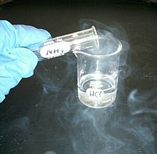](https://en.wikipedia.org/wiki/File:Hydrochloric_acid_ammonia.jpg)

[Hydrochloric acid](https://en.wikipedia.org/wiki/Hydrochloric_acid) (in [beaker](https://en.wikipedia.org/wiki/Beaker_(glassware))) reacting with [ammonia](https://en.wikipedia.org/wiki/Ammonia) fumes to produce [ammonium chloride](https://en.wikipedia.org/wiki/Ammonium_chloride) (white smoke).

[Neutralization](https://en.wikipedia.org/wiki/Neutralization_(chemistry)) is the reaction between an acid and a base, producing a [salt](https://en.wikipedia.org/wiki/Salt_(chemistry)) and neutralized base; for example, [hydrochloric acid](https://en.wikipedia.org/wiki/Hydrochloric_acid) and [sodium hydroxide](https://en.wikipedia.org/wiki/Sodium_hydroxide) form [sodium chloride](https://en.wikipedia.org/wiki/Sodium_chloride) and water:

HCl(aq) + NaOH(aq) → H2O(l) + NaCl(aq)

Neutralization is the basis of [titration](https://en.wikipedia.org/wiki/Titration), where a [pH indicator](https://en.wikipedia.org/wiki/PH_indicator) shows equivalence point when the equivalent number of moles of a base have been added to an acid. It is often wrongly assumed that neutralization should result in a solution with pH 7.0, which is only the case with similar acid and base strengths during a reaction.

Neutralization with a base weaker than the acid results in a weakly acidic salt. An example is the weakly acidic [ammonium chloride](https://en.wikipedia.org/wiki/Ammonium_chloride), which is produced from the strong acid [hydrogen chloride](https://en.wikipedia.org/wiki/Hydrogen_chloride) and the weak base [ammonia](https://en.wikipedia.org/wiki/Ammonia). Conversely, neutralizing a weak acid with a strong base gives a weakly basic salt (e.g., [sodium fluoride](https://en.wikipedia.org/wiki/Sodium_fluoride) from [hydrogen fluoride](https://en.wikipedia.org/wiki/Hydrogen_fluoride) and [sodium hydroxide](https://en.wikipedia.org/wiki/Sodium_hydroxide)).

Titration

*Main article:*[*Acid–base titration*](https://en.wikipedia.org/wiki/Acid%E2%80%93base_titration)

To determine the concentration of an acid in an aqueous solution, an acid–base titration is commonly performed. A strong base solution with a known concentration, usually NaOH or KOH, is added to neutralize the acid solution according to the color change of the indicator with the amount of base added.

Applications of acids

**In industry**

Acids are fundamental reagents in treating almost all processes in modern industry. Sulfuric acid, a diprotic acid, is the most widely used acid in industry, and is also the most-produced industrial chemical in the world. It is mainly used in producing fertilizer, detergent, batteries and dyes, as well as used in processing many products such like removing impurities

In the chemical industry, acids react in neutralization reactions to produce salts. For example, [nitric acid](https://en.wikipedia.org/wiki/Nitric_acid) reacts with [ammonia](https://en.wikipedia.org/wiki/Ammonia) to produce [ammonium nitrate](https://en.wikipedia.org/wiki/Ammonium_nitrate), a fertilizer. Additionally, [carboxylic acids](https://en.wikipedia.org/wiki/Carboxylic_acid) can be [esterified](https://en.wikipedia.org/wiki/Esterification" \o "Esterification) with alcohols, to produce [esters](https://en.wikipedia.org/wiki/Ester).

Acids are often used to remove rust and other corrosion from metals in a process known as [pickling](https://en.wikipedia.org/wiki/Pickling_(metal)).

They may be used as an electrolyte in a [wet cell battery](https://en.wikipedia.org/wiki/Wet_cell_battery), such as [sulfuric acid](https://en.wikipedia.org/wiki/Sulfuric_acid) in a [car battery](https://en.wikipedia.org/wiki/Car_battery).

**In food**

[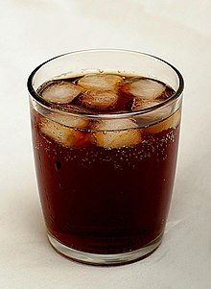](https://en.wikipedia.org/wiki/File:Tumbler_of_cola_with_ice.jpg)

Carbonated water (H2CO3 aqueous solution) is commonly added to soft drinks to make them effervesce.

[Tartaric acid](https://en.wikipedia.org/wiki/Tartaric_acid) is an important component of some commonly used foods like unripened mangoes and tamarind. Natural fruits and vegetables also contain acids.

[Citric acid](https://en.wikipedia.org/wiki/Citric_acid) is present in oranges, lemon and other citrus fruits.

[Oxalic acid](https://en.wikipedia.org/wiki/Oxalic_acid) is present in tomatoes, spinach, and especially

[Ascorbic acid](https://en.wikipedia.org/wiki/Ascorbic_acid) (Vitamin C) is an essential vitamin for the human body and is present in such foods as amla ([Indian gooseberry](https://en.wikipedia.org/wiki/Phyllanthus_emblica)), lemon, citrus fruits, and guava.

Many acids can be found in various kinds of food as additives, as they alter their taste and serve as preservatives.

[Phosphoric acid](https://en.wikipedia.org/wiki/Phosphoric_acid), for example, is a component of [cola](https://en.wikipedia.org/wiki/Cola) drinks.

[Acetic acid](https://en.wikipedia.org/wiki/Acetic_acid) is used in day-to-day life as vinegar. Citric acid is used as a preservative in sauces and pickles.

[Carbonic acid](https://en.wikipedia.org/wiki/Carbonic_acid) is one of the most common acid additives that are widely added in [soft drinks](https://en.wikipedia.org/wiki/Soft_drink). During the manufacturing process, CO2 is usually pressurized to dissolve in these drinks to generate carbonic acid. Carbonic acid is very unstable and tends to decompose into water and CO2 at room temperature and pressure. Therefore, when bottles or cans of these kinds of soft drinks are opened, the soft drinks fizz and effervesce as CO2 bubbles come out.

Certain acids are used as drugs. [Acetylsalicylic acid](https://en.wikipedia.org/wiki/Acetylsalicylic_acid) (Aspirin) is used as a pain killer and for bringing down fevers.

**In human bodies**

Acids play important roles in the human body. The hydrochloric acid present in the stomach aids digestion by breaking down large and complex food molecules.

Amino acids are required for synthesis of proteins required for growth and repair of body tissues.

Fatty acids are also required for growth and repair of body tissues.

Carbonic acid is important for maintenance of pH equilibrium in the body.

.

**Acid catalysis**

*Main article:*[*Acid catalysis*](https://en.wikipedia.org/wiki/Acid_catalysis)

Acids are used as [catalysts](https://en.wikipedia.org/wiki/Catalyst) in industrial and organic chemistry; for example, [sulfuric acid](https://en.wikipedia.org/wiki/Sulfuric_acid) is used in very large quantities in the [alkylation](https://en.wikipedia.org/wiki/Alkylation) process to produce gasoline

Common acids

**Mineral acids (inorganic acids)**

* [Hydrogen halides](https://en.wikipedia.org/wiki/Hydrogen_halides) and their solutions: [hydrofluoric acid](https://en.wikipedia.org/wiki/Hydrofluoric_acid) (HF), [hydrochloric acid](https://en.wikipedia.org/wiki/Hydrochloric_acid) (HCl), [hydrobromic acid](https://en.wikipedia.org/wiki/Hydrobromic_acid" \o "Hydrobromic acid) (HBr), [hydroiodic acid](https://en.wikipedia.org/wiki/Hydroiodic_acid" \o "Hydroiodic acid) (HI)
* Halogen oxoacids: [hypochlorous acid](https://en.wikipedia.org/wiki/Hypochlorous_acid" \o "Hypochlorous acid) (HClO), [chlorous acid](https://en.wikipedia.org/wiki/Chlorous_acid" \o "Chlorous acid) (HClO2), [chloric acid](https://en.wikipedia.org/wiki/Chloric_acid" \o "Chloric acid) (HClO3), [perchloric acid](https://en.wikipedia.org/wiki/Perchloric_acid" \o "Perchloric acid) (HClO4), and corresponding analogs for bromine and iodine
  + [Hypofluorous acid](https://en.wikipedia.org/wiki/Hypofluorous_acid) (HFO), the only known oxoacid for fluorine.
* [Sulfuric acid](https://en.wikipedia.org/wiki/Sulfuric_acid) (H2SO4)
* [Fluorosulfuric acid](https://en.wikipedia.org/wiki/Fluorosulfuric_acid) (HSO3F)
* [Nitric acid](https://en.wikipedia.org/wiki/Nitric_acid) (HNO3)
* [Phosphoric acid](https://en.wikipedia.org/wiki/Phosphoric_acid) (H3PO4)
* [Fluoroantimonic acid](https://en.wikipedia.org/wiki/Fluoroantimonic_acid) (HSbF6)
* [Fluoroboric acid](https://en.wikipedia.org/wiki/Fluoroboric_acid) (HBF4)
* [Hexafluorophosphoric acid](https://en.wikipedia.org/wiki/Hexafluorophosphoric_acid) (HPF6)
* [Chromic acid](https://en.wikipedia.org/wiki/Chromic_acid) (H2CrO4)
* [Boric acid](https://en.wikipedia.org/wiki/Boric_acid) (H3BO3)

**Carboxylic acids**

* [Acetic acid](https://en.wikipedia.org/wiki/Acetic_acid) (CH3COOH)
* [Citric acid](https://en.wikipedia.org/wiki/Citric_acid) (C6H8O7)
* [Formic acid](https://en.wikipedia.org/wiki/Formic_acid) (HCOOH)
* [Gluconic acid](https://en.wikipedia.org/wiki/Gluconic_acid) HOCH2-(CHOH)4-COOH
* [Lactic acid](https://en.wikipedia.org/wiki/Lactic_acid) (CH3-CHOH-COOH)
* [Oxalic acid](https://en.wikipedia.org/wiki/Oxalic_acid) (HOOC-COOH)
* [Tartaric acid](https://en.wikipedia.org/wiki/Tartaric_acid) (HOOC-CHOH-CHOH-COOH)

## What is a Base?

The ionic compounds that produce negative hydroxide (OH−) ions when dissolved in water are called bases. A compound containing negative nonmetal ion as well as a positive metal ion that is held together by the [ionic bond](https://byjus.com/chemistry/ionic-bond-or-electrovalent-bond/)is called an ionic compound.

But what are ions? Ions are atoms which become charged particles as a result of losing or gaining electrons. NaOH (sodium hydroxide) is an example of a base. When it dissolves in water, it generates negative hydroxide (OH−) ions and positive sodium (Na+) ions. It can be represented by the following equation:

**NaOH →H2O + OH− + Na+**

In [chemistry](https://en.wikipedia.org/wiki/Chemistry), there are three definitions in common use of the word **bas**  is a substance which dissociates in [aqueous](https://en.wikipedia.org/wiki/Aqueous_solution) solution to form [hydroxide](https://en.wikipedia.org/wiki/Hydroxide) ions OH−. These ions can react with [hydrogen ions](https://en.wikipedia.org/wiki/Hydron_(chemistry)) (H+ according to Arrhenius) from the dissociation of acids to form water in an [acid–base reaction](https://en.wikipedia.org/wiki/Acid%E2%80%93base_reaction). A base was therefore a metal hydroxide such as [NaOH](https://en.wikipedia.org/wiki/Sodium_hydroxide" \o "Sodium hydroxide) or [Ca(OH)2](https://en.wikipedia.org/wiki/Calcium_hydroxide). Such aqueous hydroxide solutions were also described by certain characteristic properties. They are slippery to the touch, can taste [bitter](https://en.wikipedia.org/wiki/Taste#bitter) and change the color of [pH indicators](https://en.wikipedia.org/wiki/PH_indicator) (e.g., turn red [litmus paper](https://en.wikipedia.org/wiki/Litmus_paper) blue).

Properties

General properties of bases include:

* Concentrated or strong bases are [caustic](https://en.wikipedia.org/wiki/Causticity) on organic matter and react violently with acidic substances.
* Aqueous solutions or molten bases dissociate in ions and conduct electricity.
* Reactions with [indicators](https://en.wikipedia.org/wiki/PH_indicator): bases turn red litmus paper blue, phenolphthalein pink, keep bromothymol blue in its natural colour of blue, and turn methyl orange-yellow.
* The [pH](https://en.wikipedia.org/wiki/PH) of a basic solution at standard conditions is greater than seven.
* Bases are bitter.

Types of Bases

* + **Strong base –** It is a compound that has an ability to remove a proton from a very weak acid. Or they completely dissociate into its ions when in water. Examples are potassium hydroxide (KOH), sodium hydroxide (NaOH).
* **Weak base –** There is incomplete dissociation when in water. The aqueous solution contains both the weak base as well as its conjugate acid. Examples are ammonia (NH3), water (H2O), [pyridine](https://byjus.com/chemistry/pyridine/) (C5H5N).
* **Neutral base –** It forms a bond with a neutral acid share an electron pair.
* **Solid base –** It is active in solid form. Examples are silicon dioxide and sodium hydroxide mounted on alumina.

Some of the examples of bases are given below.

1. Rubidium Hydroxide (RbOH)

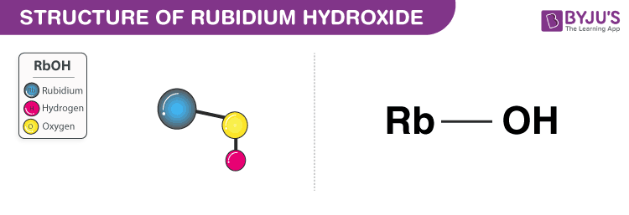

* ***Rubidium hydroxide is a strong base.***
* It appears as a greyish white solid and has a formula RbOH.
* It is also known as rubidium hydrate.
* It is prepared in a lab as it does not occur naturally.
* It has a [molecular mass](https://byjus.com/chemistry/atomic-mass-molecular-mass/) of 102.475 g/mol and density of 3.2 g/cm³.
* The boiling point is 1,390 °C melting point is 301 °C.
* It is highly corrosive.
* When comes in contact with skin causes burns.
* It is used in scientific research.

2. Zinc Hydroxide Zn(OH)2

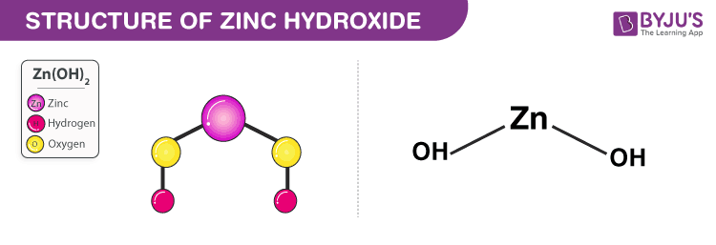

* ***Zinc hydroxide is a weak base.***
* It appears as a white powder and has a [chemical formula](https://byjus.com/chemistry/chemical-formula/) Zn(OH)2.
* It occurs naturally and can also be prepared in the lab.
* It can be obtained by adding sodium hydroxide to a zinc salt solution.
* It has a molecular mass of 99.424 g/mol and density of 3.053 g/cm³.
* It has a melting point of 125 °C.
* It is used surgical dressings as an absorbent.

Properties of Base

* Aqueous base solution dissociates into ions to conduct electricity.
* It has a ***pH value greater than 7***.
* They form salts on reacting with acids.
* They help in promoting certain chemical reactions.
* They are bitter to taste if placed in alkali solutions.
* Strong or concentrated bases are caustic.
* It changes the indicator colour from***red litmus paper to blue litmus paper***.
* It has the ability to accept protons from proton donors.
* It contains OH− ions.
* They vigorously react when in contact with acids.
* They are ***slippery to touch.***
* They conduct electricity when dissolved in water.

**Chemical Properties of Bases**

In the chemical properties of acids and bases, we now focus on bases.

* Bases change the colour of litmus from red to blue.
* They are bitter in taste.
* Bases lose their basicity when mixed with acids.
* Bases react with acids to form salt and water. This process is called [Neutralisation Reaction(Read).](https://www.toppr.com/guides/science/acids-bases-and-salts/neutralization/" \t "_blank)
* They can conduct electricity.
* Bases feel slippery or soapy.
* Some bases are great conductors of electricity.
* Bases like sodium hydroxide, potassium hydroxide, etc are used as electrolytes.
* Alkalis are bases that produce hydroxyl ions (OH-) when mixed with water.
* Strong alkalis are highly corrosive in nature whereas other [alkalis](https://www.toppr.com/guides/chemistry/the-s-block-elements/group-1-elements-alkali-metals/) are mildly corrosive.
* The pH value of bases ranges from 8-14.
* Alkalis and ammonium salts produce [ammonia](https://www.toppr.com/guides/chemistry/the-p-block-elements/ammonia/).
* Hydrogen gas is evolved when metals react with a base.
* Bases are classified on the basis of strength, concentration and acidity.
* The different kinds of acids are strong base acid, weak base acid, concentrated base, dilute base, monoacidic base, diacidic base and triacidic base.

Since the 17th century acids and bases marked and defined for the first time, their definition has been refined over the decades to reflect an enhanced knowledge of their chemical characteristics. This module presents acid/base chemistry fundamentals, including responses to neutralization.

Neutralization of acids

[](https://en.wikipedia.org/wiki/File:Hydrochloric_acid_ammonia.jpg)

[Ammonia](https://en.wikipedia.org/wiki/Ammonia) fumes from aqueous [ammonium hydroxide](https://en.wikipedia.org/wiki/Ammonium_hydroxide) (in test tube) reacting with [hydrochloric acid](https://en.wikipedia.org/wiki/Hydrochloric_acid) (in [beaker](https://en.wikipedia.org/wiki/Beaker_(glassware))) to produce [ammonium chloride](https://en.wikipedia.org/wiki/Ammonium_chloride) (white smoke).

Bases react with acids to neutralize each other at a fast rate both in water and in alcohol.[7]](https://en.wikipedia.org/wiki/Base_(chemistry)#cite_note-Gilbert-7) When dissolved in water, the strong base [sodium hydroxide](https://en.wikipedia.org/wiki/Sodium_hydroxide) ionizes into hydroxide and sodium ions:

NaOH⟶Na++OH−

and similarly, in water the acid [hydrogen chloride](https://en.wikipedia.org/wiki/Hydrogen_chloride) forms hydronium and chloride ions:

HCl+H2O⟶H3O++Cl−

When the two solutions are mixed, the H  
3O+  
 and OH−  
 ions combine to form water molecules:

H3O++OH−⟶2H2O

If equal quantities of NaOH and HCl are dissolved, the base and the acid neutralize exactly, leaving only NaCl, effectively [table salt](https://en.wikipedia.org/wiki/Table_salt), in solution.

Weak bases, such as baking soda or egg white, should be used to neutralize any acid spills. Neutralizing acid spills with strong bases, such as [sodium hydroxide](https://en.wikipedia.org/wiki/Sodium_hydroxide) or [potassium hydroxide](https://en.wikipedia.org/wiki/Potassium_hydroxide), can cause a violent exothermic reaction, and the base itself can cause just as much damage as the original acid spill.

Alkalinity of non-hydroxides

Bases are generally compounds that can neutralize an amount of acid. Both [sodium carbonate](https://en.wikipedia.org/wiki/Sodium_carbonate) and [ammonia](https://en.wikipedia.org/wiki/Ammonia) are bases, although neither of these substances contains OH−  
 groups. Both compounds accept H+ when dissolved in [protic solvents](https://en.wikipedia.org/wiki/Protic_solvent" \o "Protic solvent) such as water:

Na2CO3+H2O⟶2Na++HCO3−+OH−NH3+H2O⟶NH4++OH−

Strong bases

A strong base is a basic chemical compound that can remove a proton (H+) from (or *[deprotonate](https://en.wikipedia.org/wiki/Deprotonate" \o "Deprotonate)*) a molecule of even a very weak acid (such as water) in an acid–base reaction. Common examples of strong bases include hydroxides of alkali metals and alkaline earth metals, like NaOH and Ca(OH)

respectively. Due to their low solubility, some bases, such as alkaline earth hydroxides, can be used when the solubility factor is not taken into account. One advantage of this low solubility is that "many antacids were suspensions of metal hydroxides such as aluminium hydroxide and magnesium hydroxide." These compounds have low solubility and have the ability to stop an increase in the concentration of the hydroxide ion, preventing the harm of the tissues in the mouth, oesophagus, and stomach. As the reaction continues and the salts dissolve, the stomach acid reacts with the hydroxide produced by the suspensions. Strong bases hydrolyze in water almost completely, resulting in the [leveling effect](https://en.wikipedia.org/wiki/Leveling_effect)."[7]](https://en.wikipedia.org/wiki/Base_(chemistry)#cite_note-Gilbert-7) In this process, the water molecule combines with a strong base, due to the water's amphoteric ability; and, a hydroxide ion is released.[7]](https://en.wikipedia.org/wiki/Base_(chemistry)#cite_note-Gilbert-7) Very strong bases can even deprotonate very weakly acidic C–H groups in the absence of water. Here is a list of several strong bases:

|  |  |
| --- | --- |
| [Lithium hydroxide](https://en.wikipedia.org/wiki/Lithium_hydroxide) | LiOH |
| [Sodium hydroxide](https://en.wikipedia.org/wiki/Sodium_hydroxide) | NaOH |
| [Potassium hydroxide](https://en.wikipedia.org/wiki/Potassium_hydroxide) | KOH |
| [Rubidium hydroxide](https://en.wikipedia.org/wiki/Rubidium_hydroxide) | RbOH |
| [Cesium hydroxide](https://en.wikipedia.org/wiki/Cesium_hydroxide) | CsOH |
| [Magnesium hydroxide](https://en.wikipedia.org/wiki/Magnesium_hydroxide) | Mg(OH) 2 |
| [Calcium hydroxide](https://en.wikipedia.org/wiki/Calcium_hydroxide) | Ca(OH) 2 |
| [Strontium hydroxide](https://en.wikipedia.org/wiki/Strontium_hydroxide) | Sr(OH) 2 |
| [Barium hydroxide](https://en.wikipedia.org/wiki/Barium_hydroxide) | Ba(OH) 2 |

The cations of these strong bases appear in the first and second groups of the periodic table (alkali and earth alkali metals. ammonium hydroxides are also strong bases since they dissociate completely in water. [Guanidine](https://en.wikipedia.org/wiki/Guanidine) is a special case of a species that is exceptionally stable when protonated, analogously to the reason that makes [perchloric acid](https://en.wikipedia.org/wiki/Perchloric_acid" \o "Perchloric acid) and [sulfuric acid](https://en.wikipedia.org/wiki/Sulfuric_acid) very strong acids.

Weak bases

A weak base is one which does not fully ionize in an [aqueous solution](https://en.wikipedia.org/wiki/Aqueous_solution), For example, [ammonia](https://en.wikipedia.org/wiki/Ammonia) transfers a proton to water according to the equation

��3(��)+�2�(�)⇌��4+(��)+��−(��)

Solid bases

Examples of solid bases include:

* Oxide mixtures: SiO2, Al2O3; MgO, SiO2; CaO, SiO2[14]](https://en.wikipedia.org/wiki/Base_(chemistry)#cite_note-Tanabe-14)
* Mounted bases: LiCO3 on silica; NR3, NH3, KNH2 on alumina; NaOH, KOH mounted on silica on alumina[14]](https://en.wikipedia.org/wiki/Base_(chemistry)#cite_note-Tanabe-14)
* Inorganic chemicals: BaO, KNaCO3, BeO, MgO, CaO, KCN[14]](https://en.wikipedia.org/wiki/Base_(chemistry)#cite_note-Tanabe-14)
* Anion exchange resins[14]](https://en.wikipedia.org/wiki/Base_(chemistry)#cite_note-Tanabe-14)
* Charcoal that has been treated at 900 degrees Celsius or activates with N2O, NH3, ZnCl2-NH4Cl-CO2[14]](https://en.wikipedia.org/wiki/Base_(chemistry)#cite_note-Tanabe-14)

Uses of bases

* Sodium hydroxide is used in the manufacture of soap, paper, and the synthetic fiber [rayon](https://en.wikipedia.org/wiki/Rayon).
* Calcium hydroxide (slaked lime) is used in the manufacture of bleaching powder.
* Calcium hydroxide is also used to clean the sulfur dioxide, which is caused by the exhaust, that is found in power plants and factories.
* Magnesium hydroxide is used as an 'antacid' to neutralize excess acid in the stomach and cure indigestion.
* [Sodium carbonate](https://en.wikipedia.org/wiki/Sodium_carbonate) is used as washing soda and for softening hard water.
* [Sodium bicarbonate](https://en.wikipedia.org/wiki/Sodium_bicarbonate) (or sodium hydrogen carbonate) is used as baking soda in cooking food, for making baking powders, as an antacid to cure indigestion and in soda acid fire extinguisher.
* [Ammonium hydroxide](https://en.wikipedia.org/wiki/Ammonium_hydroxide) is used to remove grease stains from clothes

What is Alkali?

* Alkali is a base.
* It is a base that dissolves in water.
* This is very important to remember-
* Not all bases are alkali but all alkali is base.
* It is a basic salt alkali earth metal or [alkali metal](https://byjus.com/jee/alkali-metals/).
* On adding alkali to acid the pH of the mixture increase.
* On adding acid to alkali the pH decreases due to the removal of alkali.
* Neutralization is a reaction in which removal of alkalinity or acidity occurs.

**PHYSICAL PROPERTIES OF ALKALIS:**

1. Alkalis have a BITTER taste & have a SOAPY touch  
2. Alkalis turn RED litmus paper BLUE  
3. Alkalis have a pH value > 7  
4. Alkalis are CAUSTIC  
5. Alkalis **CONDUCT ELECTRICITY** due to the presence of **MOBILE IONS** in solution

**CHEMICAL PROPERTIES OF ALKALIS:**

1. **Neutralization** Reaction (Dilute Acid + Alkali→Salt + Water)

2. Alkali react with **Ammonium Salts** to produce **Ammonia Gas** when heated gently  
**Alkali + Ammonium Salt→Salt + Ammonia Gas + Water Heat gently]**

3. **Precipitation** of **Insoluble Metal Hydroxides** from aqueous solutions containing salts using common alkalis such as NaOH & NH4OH  
Metal Ions in Solution + Alkali→Insoluble Metal Hydroxide (PRECIPITATES)

A chemical base (or alkaline) is a substance that accepts H+ or hydrogen ions. It dissociates in water and is a good conductor of electricity. A base turns litmus paper blue, which indicates its alkalinity. An acid is a compound that dissolves in water to release hydrogen ions. Acids and bases are generally chemically active in that they can react with many other substances. As a result, they are commonly found in various household applications, especially as cleaners and in the kitchen.

## Baking Soda

Baking soda is the common name for sodium bicarbonate, known chemically as NaHCO3. It is also called bicarbonate of soda, cooking soda and bread soda. Baking soda is produced by the reaction of carbon dioxide, ammonia, sodium chloride (salt) and calcium carbonate in water. Naturally occurring deposits of the compound are mined from geological formations of the Eocene age (approximately 48 million years ago). The Green River Formation (Piceance Basin) in Colorado is a major source of sodium bicarbonate. Baking soda is primarily used for baking. It reacts with other ingredients to release carbon dioxide, which helps the dough rise. A diluted solution of household baking soda can treat heartburn and indigestion. It functions as a mouthwash, treats gum diseases and relieves insect bites. A hydrogen peroxide and sodium bicarbonate paste can be used as an alternative to commercial toothpaste. Baking soda is an effective cleaning agent and removes heavy stains (wine, tea and coffee) from cups and fabric.

## Diluted Soaps

Potassium or sodium hydroxide (KOH or NaOH) react with triglycerides to form soap (the process is called saponification, the reaction of a strong alkali with fats and oils). Soap is alkaline in nature and is an effective cleansing agent. It is a useful mild antiseptic and can treat heavy metal poisoning. A diluted solution of soap makes an effective insecticide when sprayed on garden plants.

## Household Ammonia

Household ammonia (ammonium hydroxide) is a common base, and is an effective tarnish and stain remover. It is used to clean gold and silver jewelry, porcelain, glass, stainless steel, brassware and a variety of stains (blood, perspiration, red wine stains and pen markings).

## Household Vinegars

Vinegar is a common household acid that is made from fermented ethanol, acetic acid and small amounts of citric acid and tartaric acid. There are various varieties of vinegar, including malt, wine, apple cider, palm, date, balsamic and honey vinegar. Vinegar is commonly used in the preparation of pickles, vinaigrettes, salad dressings and sushi rice and flavorings. White vinegar is a common cleaning agent, and is used to remove tough deposits from coffee makers, glass and other smooth surfaces. It is also effective against lawn weeds.

## Citric Acid

Citric acid is used as an additive in foods, as a preservative and an effective cleaning agent. It is naturally found in certain fruits, such as oranges and lemons.

Household Acids

Here is a list of common household acids:

* Vinegar – weak [acetic acid](https://sciencenotes.org/what-is-glacial-acetic-acid/)
* Lemon juice – citric acid and some ascorbic acid
* Any citrus fruit – citric acid and some ascorbic acid
* Most other fruits – citric acid, possibly tartaric, oxalic, or malic acid
* Carbonated soda – phosphoric, carbonic, and sometimes citric acid
* Battery acid – sulfuric acid
* Aspirin – acetylsalicylic acid
* Muriatic acid – hydrochloric acid
* Sour candies – citric acid
* Hydrogen peroxide
* Yogurt – lactic acid
* Baker’s ammonia – ammonium bicarbonate
* Brewed coffee or tea
* Most alcoholic beverages
* Stomach acid and vomit – hydrochloric acid
* Urine (only slightly acidic)

Household Bases

Here is a list of common household bases:

* Ammonia
* Baking soda – [sodium bicarbonate](https://sciencenotes.org/why-is-baking-soda-called-sodium-bicarbonate/)
* Washing soda – sodium carbonate
* Soap – Either sodium or potassium hydroxide
* Detergents
* Shampoo
* Borax
* Chlorine bleach
* Toothpaste
* Egg whites
* Chalk – calcium carbonate
* Drain cleaner
* Antacids – magnesium hydroxide
* Plaster

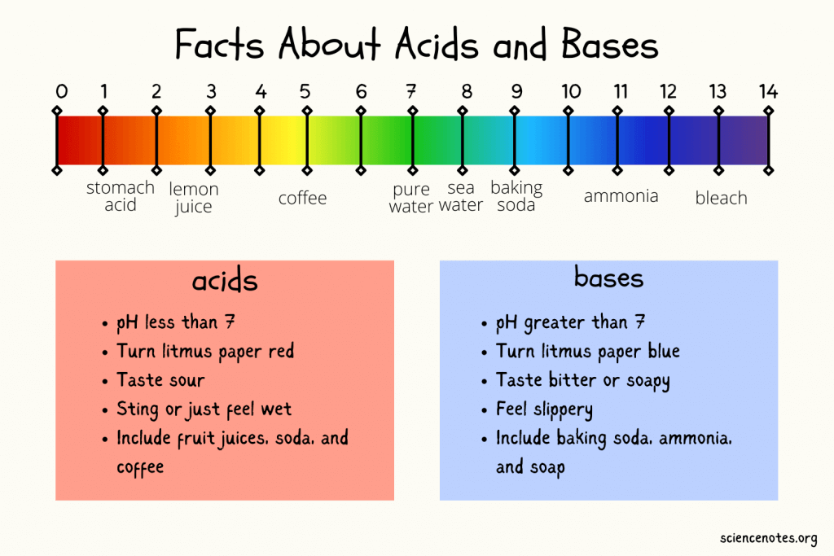

Ph of common stuff

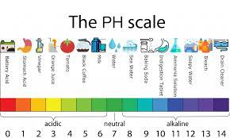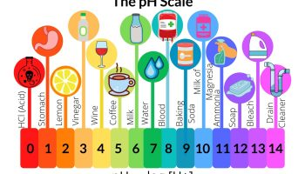

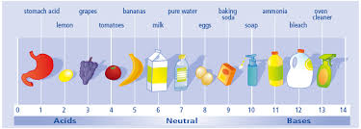

Indicators  
**Indicators** are substances whose solutions change color due to changes in pH. These are called acid-base indicators. They are usually weak acids or bases, but their conjugate base or acid forms have different colors due to differences in their absorption spectra.

| **Name** | **Acid Color** | **pH Range of Color Change** | **Base Color** |
| --- | --- | --- | --- |
| Methyl violet | Yellow | 0.0 - 1.6 | Blue |
| Thymol blue | Red | 1.2 - 2.8 | Yellow |
| Methyl orange | Red | 3.2 - 4.4 | Yellow |
| Bromocresol green | Yellow | 3.8 - 5.4 | Blue |
| Methyl red | Red | 4.8 - 6.0 | Yellow |
| Litmus | Red | 5.0 - 8.0 | Blue |
| Bromothymol blue | Yellow | 6.0 - 7.6 | Blue |
| Thymol blue | Yellow | 8.0 - 9.6 | Blue |
| Phenolphthalein | Colorless | 8.2 - 10.0 | Pink |
| Thymolphthalein | Colorless | 9.4 - 10.6 | Blue |
| Alizarin yellow R | Yellow | 10.1 - 12.0 | Red |

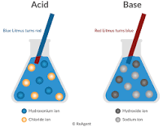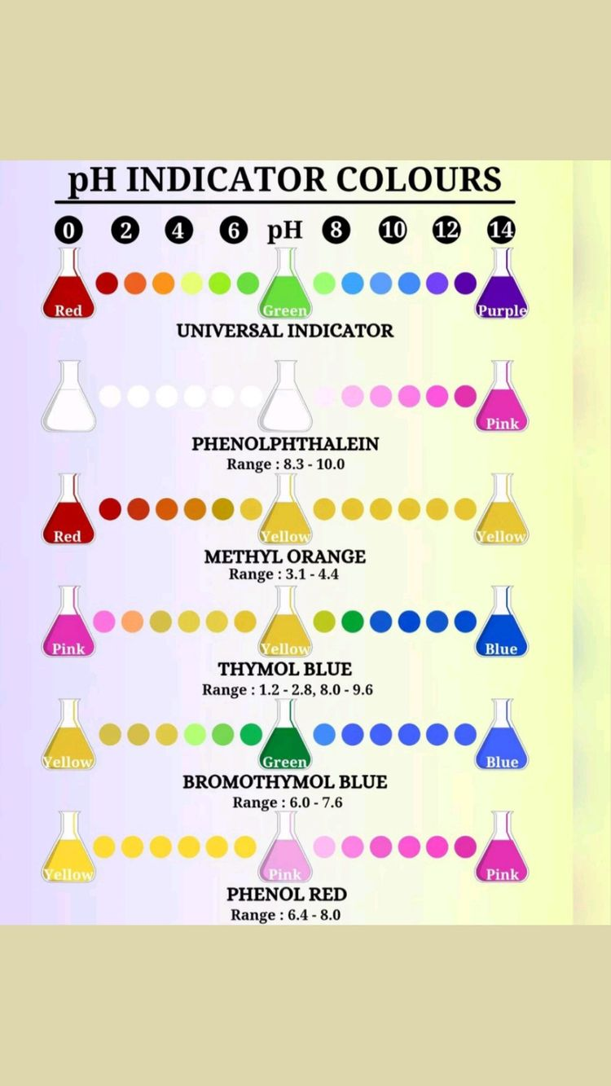

Titration

Titration is a common laboratory method of quantitative chemical analysis to determine the concentration of an identified analyte

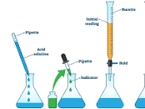 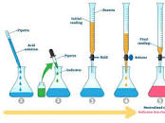

1. **Titration –** A process where a solution of known strength is added to a certain volume of a treated sample containing an indicator.
2. **Titrant –** A solution of known strength of concentration used in the titration.
3. **Titrand –** The titrand is any solution to which the titrant is added and which contains the ion or species being determined.
4. **Equivalence point –**The point at which just an adequate reagent is added to react completely with a substance.
5. Titration Procedure
6. The process of titration involves the preparation of a titrant/titrator, which is a standard solution whose volume and concentration are predetermined. This titrant is then made to react with the analyte until some endpoint or equivalence point is reached, at which stage the concentration of the analyte can be determined by measuring the amount of titrant consumed. Alternatively, titration is the concept of stoichiometry that is applied to find the unknown concentration of a solution.
7. As for the steps of the procedure, a very precise amount of the analyte is added in a beaker or Erlenmeyer flask. A small amount of indicator (such as phenolphthalein) is placed underneath a calibrated burette or chemistry pipetting syringe which consists of the titrant.
8. Small volumes of the titrant are added to the analyte and indicator. This will go on until the indicator changes colour in reaction to the titrant saturation threshold. At this point, it will represent that we have come to the endpoint of the titration. Basically in this case, the amount of titrant balances the amount of analyte present during the reaction.

## Acid-Base Titration (Acidimetoy or Alkalimetry)

Acid-base titrations mainly depend on the neutralization between an acid and a base when mixed in solution. More significantly, the strength of an acid is determined by using a standard solution of a base. This process is also called acidimetry.

Acids can be classified into strong or weak acids depending on the amount of dissociation to give H+ ions when dissolved in water. If an acid solution of known concentration is titrated against a strong base, the concentration of acid can be calculated, considering the fact that the neutralization reaction reaches completion. For the same fact, only a strong base is used for the titration process. So in this case, the acid solution is the titrate and the strong base is the titrant or the standard solution.

### The Procedure of Acid-Base Titration

* The required volume of the base is taken whose concentration is known in a pipette ad is poured into the titrating flask.
* The acid whose concentration is unknown is taken in the Burette and is allowed to react with the base drop by drop.
* An indicator that is used for detecting the endpoint is also added in the titration flask.
* When the reaction reaches completion the colour of the solution in the titration flask changes due to the presence of the indicator.
* The indicator used for this purpose can be [phenolphthalein](https://byjus.com/chemistry/phenolphthalein/) which forms pink colour in basic solution and is colourless in acid and neutral solution.

Therefore the endpoint is detected when the pink-coloured solution turns colourless.

